1. **Average Attrition rate for all Departments**

/*Q1 .Average Attrition rate for all Departments*/

SELECT Department,

AVG(CASE WHEN Attrition = 'Yes' THEN 1 ELSE 0 END) AS AverageAttritionRate

FROM hr_analytics

GROUP BY Department;

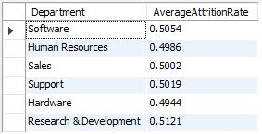

1. **Average Hourly rate of Male Research Scientist**

/*Q2 .Average Hourly rate of Male Research Scientist*/

SELECT JobRole,Gender,

AVG(HourlyRate) AS AverageHourlyRate

FROM hr_analytics where JobRole='Research Scientist' and Gender='Male';



1. **Attrition rate Vs Monthly income stats**

/*Q3.Attrition rate Vs Monthly income stats*/

SELECT Department,

AVG(CASE WHEN Attrition = 'Yes' THEN 1 ELSE 0 END) AS AverageAttritionRate,

AVG(MonthlyIncome)

FROM hr_analytics

GROUP BY Department

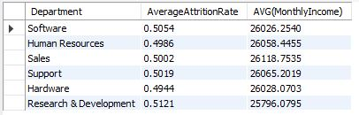

1. **Average working years for each Department**

/*Q4. Average working years for each Department*/

SELECT Department,

AVG(TotalWorkingYears) AS AverageWorkingYears

FROM hr_analytics

GROUP BY Department

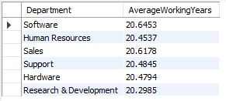

1. **Job Role Vs Work life balance**

/*Q5.Job Role Vs Work life balance*/

SELECT JobRole, AVG(WorkLifeBalance) AS WorkLifeBalance

FROM hr_analytics

GROUP BY JobRole

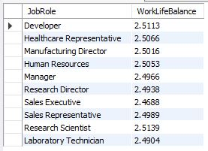

1. **Attrition rate Vs Year since last promotion relation**

/*Q6.Attrition rate Vs Year since last promotion relation*/

SELECT AVG(CASE WHEN Attrition = 'Yes' THEN 1 ELSE 0 END) AS AverageAttritionRate, YearsSinceLastPromotion

FROM hr_analytics

GROUP BY YearsSinceLastPromotion

